C:\Users\Admin\AppData\Local\Microsoft\Windows\Temporary Internet Files\Content.IE5\E8EW9FVK\001da.tiff

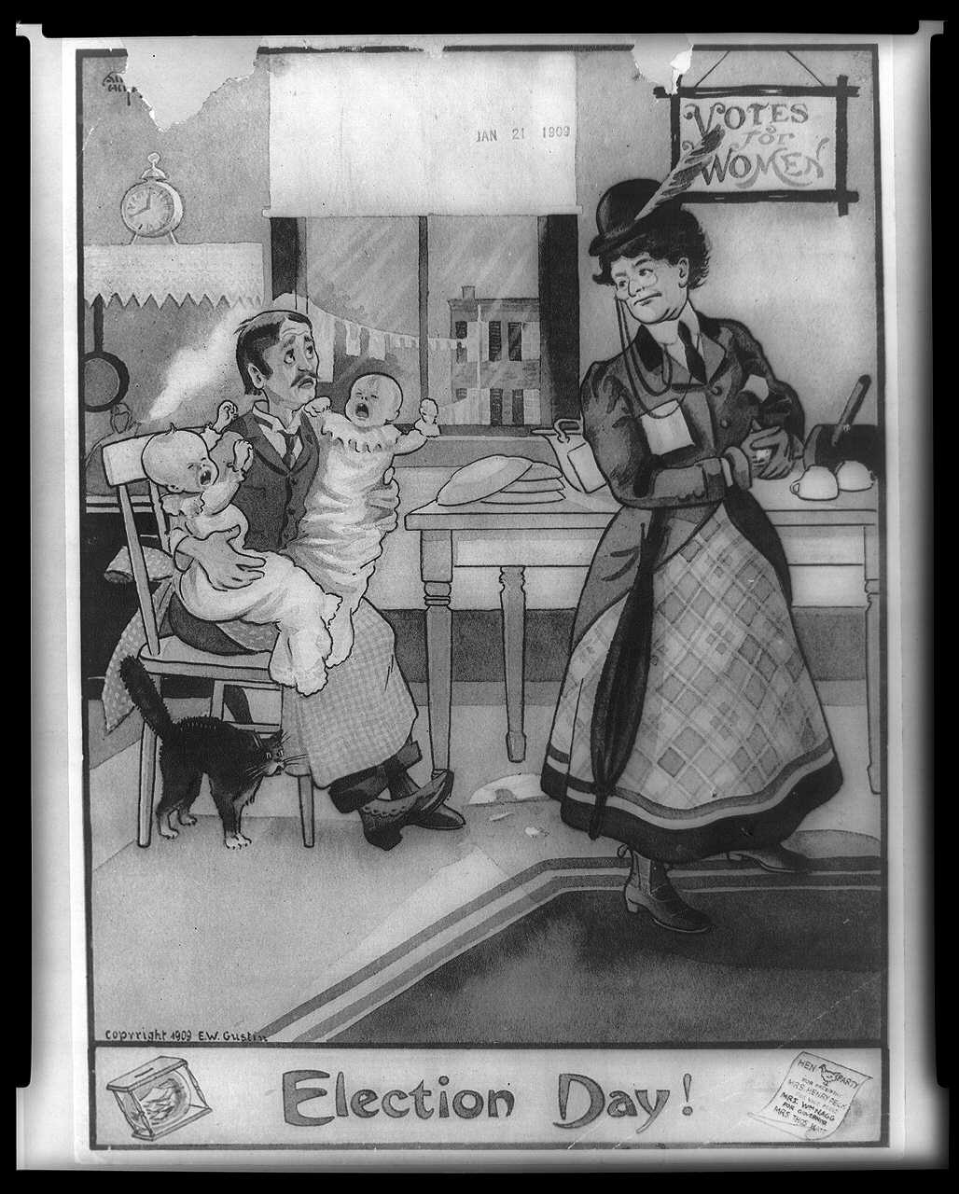

[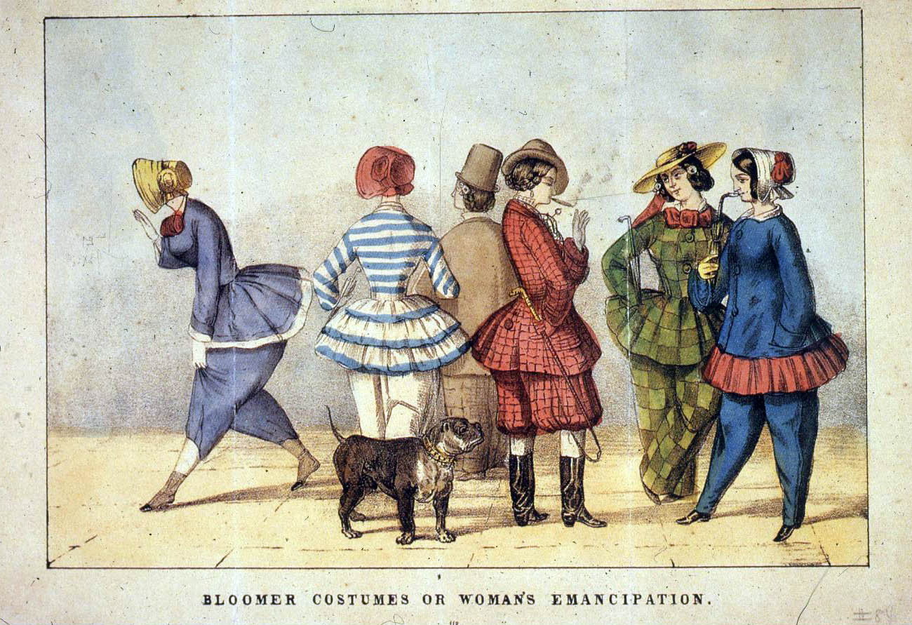](http://www.google.com/url?sa=i&rct=j&q=&esrc=s&source=images&cd=&cad=rja&uact=8&docid=jkZ2mE_QXVXrWM&tbnid=6dq5pmLWrdqecM:&ved=0CAYQjRw&url=http://marchand.historyproject.ucdavis.edu/tag/anti-suffrage/&ei=WsAlU5LoBqPsyQHc7oG4Bg&bvm=bv.62922401,d.aWc&psig=AFQjCNEnN5163mTI-tHqxLs6p7ZQ17o23g&ust=1395069336077854)