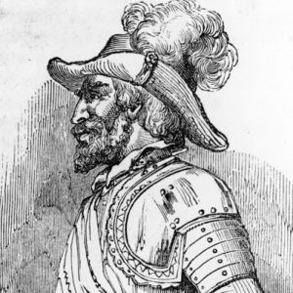
Student Developed Lesson
Name

Period
Date
How Do I Know That
Actually Happened?
Ponce de Leon and the Fountain of Youth .
Questionaire
- What was Juan Ponce de Leon looking for when he discovered Florida?

- How do you know?

- Where in Florida did he land?

- How do you know?

- Did he find the Fountain of Youth?

- How do you know?

- Why do you suppose you have been taught differently about the Ponce de Leon in the past?

- What questions do you still have about Juan Ponce de Leon?

