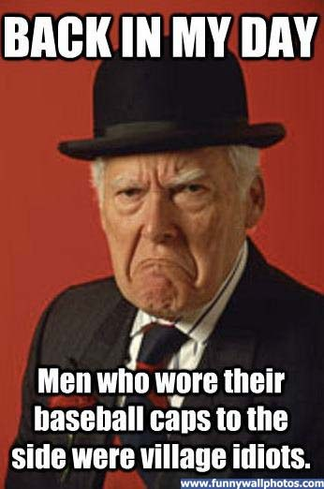
Life Before…
Communication:
1832 Telegraph Samuel Morse
1876 Telephone Alexander Graham Bell
1895 Radio Guglielmo Marconi
1927 Television Philo Farnsworth
1969 Internet Leonard Kleinrock / Douglas Engelbart
(1995 – available for public use)
1983 Cell Phone John Marshall / Martin Cooper
For Your Home:
1741 Wood Stove Benjamin Franklin
1822 Photograph Joseph Niepce
1857 Toilet Paper Joseph Gayetty
1868 Water Heater Benjamin Maughen
1876 Bed Springs Zalmon Simmons
1878 Electric Light Thomas Edison
1880 Modern Flush Toilet Thomas Crapper
1880 Clawfoot Bathtub David Buick
1889 Residential Electric Thomas Edison
1902 Air Conditioning Willis Carrier
1914 Refrigerator Fred Wolf
1914 Gas Lawn Mower Ideal Power Motor Company
1945 Microwave Oven Percy Spencer
Transportation:
1830 Steam Train Peter Cooper
1885 Safety Bicycle J.K.Stanley
1894 Automobile Carl Benz
1903 Airplane Orville and Wilbur Wright
Sports:
644 Hackisack Kemari….Japan
1574 Golf St. Andrews Golf Club
1815 Soccer (rules) Easton College
1845 Baseball (rules) Alexander Cartwright
1849 Baseball Cap NY Knickerbockers
1873 Football (rules) Rutgers/Yale/Columbia/Princeton
1877 Baseball Glove Albert Spalding
1892 Basketball Dr. James Naimith

Things You May Know:
1869 Chewing Gum William Semple
1871 Tennis Shoe Samuel Plimsoll
1873 Blue Jeans Levi Strauss
1886 Coca Cola John Pemberton
1891 Cereal John Kellogg
1892 Toothpaste Dr. Washington Sheffield
1900 Hamburger Louis Lassen
1913 T-Shirt US Navy
1914 Bra Mary Phelps Jacob

