How well do you know "Gettysburg"
Question 1
Aside from the Narrator's opening, what is the first line of the movie Gettysburg?
"Two brigades of Federals"
"Federal Calvary"
"Where's General Longstreet?"
"Halt!"
"Whoa girl"
Question 2
In the movie the second day's battle focuses on the 20th Maine and the fight for ___________________
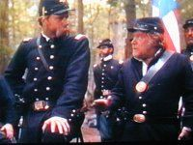
Question 3
During the second days fighting Col. Chamberlain is almost shot, what does the bullet actually hit?
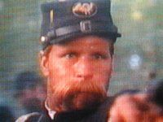

Question 4
Which one of these characters is not shot during Pickett's Charge at the end of the film?
General Kemper
General Hancock
General Armistead
General Garnett
General Hood
Question 5
Finish this line of dialogue. "Up men up and to your posts. And let no man forget today that you are from ______________________________________________________!"
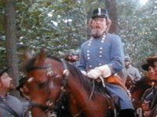
Question 6
What do the Federal soldiers chant as the Confederates retreat following Pickett's Charge?
Victory!
Hancock!
Gettysburg!
Fredricksburg!
Antietam!

Question 7
What was Harrison the confederate scout's occupation before the war?
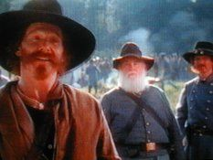
Lawyer
Doctor
Merchant
Actor
Sailor
Question 8
The 120 men that are send to Col. Chamberlain and the 20th Maine were originally from what regiment?
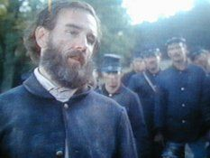
The 1st Maine
The 2nd New York
The 10th Maine
The 2nd Maine
The 4th Maine

Question 9
What is Col. Chamberlain's brother's name?
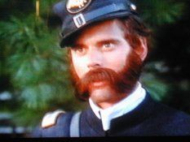
Jeff
Tom
William
Ben
Alex
Question 10
Who plays the role of General Robert E. Lee in Gettysburg?
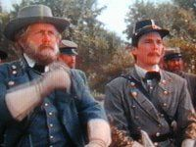

Question 11
What is General Buford's reply when General Reynolds asks "Can you hold?"
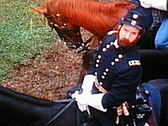
I reckon I can
No sir, we're breakin'
Yes sir, I believe I can
Not for much longer
How far back are your boys?
Question 12
Who is the first General to get shot in the film?
General Reynolds
General Longstreet
General Heth
General Buford
General Armistead
Question 13
Finish this line of dialogue. "I don't like going in without Pickett, it’s like going in ________________"
